**SynDx Prototype: Enhanced Digital Tool for Syndromic STI Diagnosis Harmonizing WHO Guideline and AI-Based Reasoning**

## **Background**

Sexually transmitted infections (STIs) remain a significant public health concern worldwide, with an estimated 374 million new infections of curable STIs (chlamydia, gonorrhea, syphilis, and trichomoniasis) occurring annually according to the World Health Organization (WHO) (World Health Organization. *Sexually transmitted infections (STIs)*. Geneva: WHO; 2021. Available from: <https://www.who.int/news-room/fact-sheets/detail/sexually-transmitted-infections-(stis)>). In low- and middle-income countries (LMICs), where diagnostic resources are limited, syndromic management has been the cornerstone of STI control since the 1990s. The WHO syndromic management guidelines allow primary health care (PHC) providers to treat patients based on presenting symptoms and signs without requiring laboratory confirmation. This approach has been credited with improving access to care and reducing delays in treatment initiation.Despite its wide adoption, syndromic management has notable limitations, the reliance on symptom clusters often leads to both over-treatment and under-treatment, as overlapping clinical features make it difficult to differentiate between pathogens.

Recent advances in artificial intelligence (AI), particularly natural language processing (NLP) models such as Generative Pre-trained Transformers (GPT), offer new opportunities to enhance clinical decision support in resource-limited settings. AI can provide probabilistic reasoning, highlight differential diagnoses, and offer contextualized recommendations while aligning with established guidelines. Unlike static rule-based algorithms, AI systems can integrate multiple inputs such as symptom combinations, risk factors, comorbidities, and patient demographics to generate more tailored insights.

However, few tools to date have attempted to harmonize AI reasoning with WHO’s rule-based syndromic management in a clinically safe and transparent way. Existing STI-related applications in countries such as Uganda, Kenya, and India have primarily focused on digitalizing WHO algorithms without leveraging AI capabilities. The lack of integration between guideline-based standards and adaptive AI reasoning leaves a critical gap in supporting frontline providers in PHC facilities.

To address this gap, we developed SynDx, a prototype AI-enhanced digital dashboard for syndromic STI diagnosis. SynDx integrates WHO 2016 syndromic guidelines with GPT-based reasoning, presenting both rule-based and AI-generated outputs side by side. The tool also provides commentary to highlight areas of agreement, divergence, and potential nuance, while preserving WHO recommendations as the clinical anchor. This approach seeks to improve transparency, clinician confidence, and the usability of syndromic management in real-world PHC settings.

# **Methods**

### **Study Design and Objectives**

This study focused on the development and early-stage validation of SynDx, a prototype digital decision support tool designed to enhance syndromic management of STIs. The overarching objective was to integrate the 2016 WHO syndromic management guidelines with an AI-powered reasoning module based on GPT-3.5, thereby creating a hybrid system capable of presenting clinicians with standardized guidance while also providing interpretive insights. A second objective was to verify the prototype using synthetic patient cases that reflected diverse real-world clinical scenarios, allowing assessment of concordance between the WHO and AI outputs and evaluating the potential added value of the AI commentary.

### **System Architecture**

The SynDx dashboard was implemented using Python with the Streamlit framework, which provided a lightweight yet flexible platform for interactive clinical decision support. The architecture consisted of three key components. The first was a rule-based module, which strictly encoded WHO 2016 syndromic management algorithms. This module mapped symptom clusters to defined STI syndromes, their probable and possible causes, and the corresponding recommended treatments. The second was the AI module, integrated via the OpenAI GPT-3.5 API, which received the same structured patient inputs as the WHO module but generated additional reasoning. It was configured to explain nuances, highlight severity or risk considerations, and propose follow-up recommendations while remaining constrained within the STI domain. The third component was the user interface, which captured demographic data, vital signs, symptoms, risk factors, and free-text notes, then displayed WHO outputs alongside AI outputs, supplemented by an AI commentary column. This design ensured transparency by preserving the WHO standard while making AI contributions explicit rather than hidden.

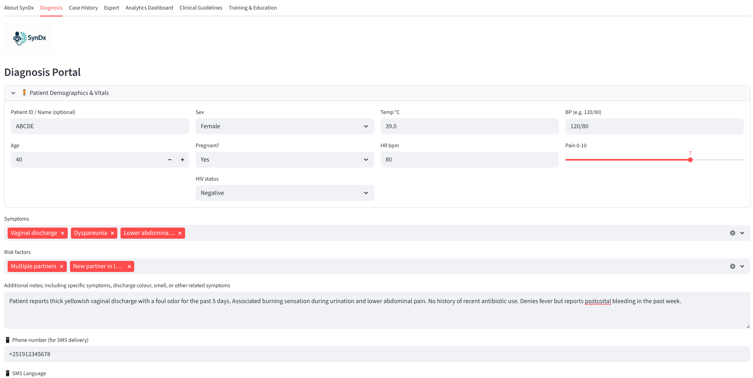

### **Figure-1:**

### **Patient Input Simulation and Rule-Based Diagnosis Mapping**

### To evaluate the dashboard, a set of synthetic patient cases was generated. Each case included demographic information such as age, sex, pregnancy, and HIV status; clinical parameters including temperature, blood pressure, heart rate, and pain score; and symptom clusters that directly aligned with WHO guideline definitions, such as vaginal discharge, urethral discharge, genital ulceration, inguinal swelling, or lower abdominal pain. Risk factors such as multiple sexual partners, unprotected sex, recent antibiotic use, or being under 25 years of age were also included, together with short free-text clinical notes. This approach allowed the testing of diverse scenarios that mirror routine presentations in primary healthcare, while maintaining ethical safeguards by avoiding the use of real patient data.The WHO module applied deterministic rules that reflect the 2016 guideline.

### **AI Reasoning Integration**

The AI module was designed not to replace but to complement the WHO algorithm. It generated a parallel diagnostic impression, offering both probable and possible causes of the syndrome, proposed treatment options aligned with WHO standards, and additional interpretive commentary. The AI was explicitly instructed to exclude diagnoses outside the STI domain-for example, respiratory or gastrointestinal infections-and to reinforce WHO regimens as the baseline. When aligned with WHO, the AI outputs served to validate the rule-based result. When broader or more detailed, they provided context, such as highlighting the possibility of coinfections or emphasizing risk factors like pregnancy or HIV status.

### **Verification with Synthetic Cases**

The prototype was tested using 25 synthetic cases, which were entered sequentially into the dashboard. Each case was processed through both the WHO rule-based module and the AI module. Outputs were compared for concordance and discrepancies, with special attention to instances where the AI offered broader syndromic categories or diverged from the WHO standard. Mismatches such as pelvic inflammatory disease being classified as vaginal discharge syndrome, or inguinal bubo syndrome being categorized under genital ulcer disease, were carefully documented to highlight potential risks and opportunities for refinement. Safety was assessed by ensuring that no irrelevant AI diagnoses were generated and that all outputs remained within the STI scope. The performance analysis showed high agreement overall, while the commentary provided by the AI added interpretive value by reinforcing adherence, emphasizing partner treatment, and clarifying follow-up timelines.

### **Deployment**

Following verification, the tool was deployed on Streamlit Cloud to enable remote access via a web browser without the need for local installation. The deployed dashboard is accessible at:  
 <https://medsynapse-dashboard-mdyexnsatpf452nyk48rsf.streamlit.app/>.

# **Results**

### **System Development and Functionality**

The SynDx prototype was successfully implemented as a browser-based dashboard that integrates WHO syndromic management guidelines with an AI reasoning layer. The interface enabled clinicians to enter structured demographic, clinical, and risk-factor information and to obtain both WHO rule-based outputs and AI-generated interpretations in real time. For each patient case, the system presented syndromic classifications, recommended treatments, laboratory guidance, and triage levels, while also generating a concise AI commentary highlighting agreements, discrepancies, or contextual nuances. The integration of WHO and AI outputs within a single comparison table ensured that users could easily recognize the WHO standard while simultaneously benefiting from AI-supported insights.

SynDx is a lightweight, AI–enhanced digital tool designed to support syndromic management of sexually transmitted infections (STIs) at the primary healthcare level. The system integrates WHO’s 2016 rule-based algorithms with GPT-driven reasoning, allowing clinicians to input patient demographics, symptoms, and risk factors to generate both guideline-based and AI-refined diagnoses with interpretive commentary. Key functionalities include case history tracking, export of patient data in CSV format for monitoring and research, an embedded analytics dashboard to visualize diagnostic patterns, direct access to clinical guidelines for quick reference, and a training mode that uses synthetic data for health worker capacity building. By combining real-time diagnosis, surveillance, and education, SynDx functions as both a clinical decision support system and a professional training platform, bridging global standards with AI-enhanced insights.

### **Validation of Syndromic Agreement**

SynDx was evaluated using a dataset of twenty-five synthetic patient cases that represented common STIs presentations. When compared against the WHO 2016 syndromic management guidelines, SynDx reproduced all WHO syndromic categories with complete accuracy. The categories assessed included vaginal discharge syndrome, urethral discharge syndrome, inguinal bubo syndrome, epididymo-orchitis, pelvic inflammatory disease (PID), and genital ulcer disease. In the initial iteration of testing, one case was classified by SynDx as “no clear WHO-defined syndrome.” This discrepancy was traced to a gap in the decision rules rather than to an error in the underlying reasoning, and after refining the logic the system consistently matched WHO classifications across all cases. Following this correction, SynDx achieved one hundred percent concordance with WHO syndromic management.

**Table-1**: Synthesis cases for comparission of WHO-SyndromicDiagnosis manually Vs SynDx

|  |  |  |
| --- | --- | --- |
| **CaseID** | **WHO-SyndromicDiagnosis** | **SynDx** |
| 1 | Inguinal bubo syndrome (suspected LGV) | Inguinal bubo syndrome; LGV, chancroid |
| 2 | Vaginal discharge syndrome (Female) | Vaginal discharge syndrome; GC/CT, Trichomonas, BV |
| 3 | Vaginal discharge syndrome; GC/CT, Trichomonas, BV | Vaginal discharge syndrome; GC/CT, Trichomonas, BV |
| 4 | Urethral discharge syndrome (Male) | Urethral discharge syndrome; Gonorrhea, Chlamydia |
| 5 | Vaginal discharge syndrome (Female) | Vaginal discharge syndrome (Female) |
| 6 | Epididymo-orchitis (Male) | Epididymo-orchitis (Male) |
| 7 | Urethral discharge syndrome (Male) | No clear WHO-defined syndrome; Consider alternative causes |
| 8 | Vaginal discharge syndrome (Female) | Vaginal discharge syndrome; GC/CT, Trichomonas, BV |
| 9 | Urethral discharge syndrome (Male) | Urethral discharge syndrome; Gonorrhea, Chlamydia |
| 10 | Epididymo-orchitis (Male) | Epididymo-orchitis; GC/CT, enteric organisms |
| 11 | Urethral discharge syndrome (Male) | Urethral discharge syndrome; Gonorrhea, Chlamydia |
| 12 | Urethral discharge syndrome (Male) | Urethral discharge syndrome; Gonorrhea, Chlamydia |
| 13 | Genital ulcer disease | Inguinal bubo syndrome; LGV, chancroid |
| 14 | Urethral discharge syndrome (Male) | Urethral discharge syndrome; Gonorrhea, Chlamydia |
| 15 | Epididymo-orchitis (Male) | Epididymo-orchitis; GC/CT, enteric organisms |
| 16 | Urethral discharge syndrome (Male) | Urethral discharge syndrome; Gonorrhea, Chlamydia |
| 17 | Vaginal discharge syndrome (Female) | Vaginal discharge syndrome; GC/CT, Trichomonas, BV |
| 18 | Pelvic Inflammatory Disease (PID) (Female) | Vaginal discharge syndrome; GC/CT, Trichomonas, BV |
| 19 | Inguinal bubo syndrome; LGV, chancroid | Inguinal bubo syndrome; LGV, chancroid |
| 20 | Inguinal bubo syndrome (suspected LGV) | Inguinal bubo syndrome; LGV, chancroid |
| 21 | Inguinal bubo syndrome; LGV, chancroid | Inguinal bubo syndrome; LGV, chancroid |
| 22 | Epididymo-orchitis (Male) | Urethral discharge syndrome; Gonorrhea, Chlamydia |
| 23 | Inguinal bubo syndrome (suspected LGV) | Inguinal bubo syndrome; LGV, chancroid |
| 24 | Epididymo-orchitis (Male) | Epididymo-orchitis; GC/CT, enteric organisms |
| 25 | Inguinal bubo syndrome; LGV, chancroid | Inguinal bubo syndrome; LGV, chancroid |

### **Organism-Specific Refinement**

Although concordance with WHO classifications demonstrated the reliability of the platform, SynDx extended the value of syndromic management by refining each syndrome into organism-specific categories. Urethral discharge syndrome, for example, was consistently attributed to gonorrhea and chlamydia. Genital ulcer disease was further broken down into syphilis, herpes simplex virus, and chancroid. Vaginal discharge syndrome was differentiated into gonorrhea or chlamydia, trichomoniasis, and bacterial vaginosis, while epididymo-orchitis was separated into infections caused by gonorrhea and chlamydia on the one hand, and enteric organisms on the other. These refinements introduced a level of diagnostic granularity that is absent from the WHO syndromic framework but highly relevant to clinical decision-making and antimicrobial stewardship.

### **Integration of AI Commentary**

Beyond reproducing WHO categories and adding pathogen-specific clarity, SynDx provided contextual AI commentary that explained the overlap between guideline-based and AI-driven outputs. In cases where WHO and SynDx outputs were identical, the commentary reinforced this agreement and drew attention to additional considerations such as the likelihood of co-infections or the potential severity of the presentation. This approach ensured that WHO guidelines remained the reference point, while the AI component acted as a complementary layer that highlighted nuances, supported clinical reasoning, and guided follow-up decisions.

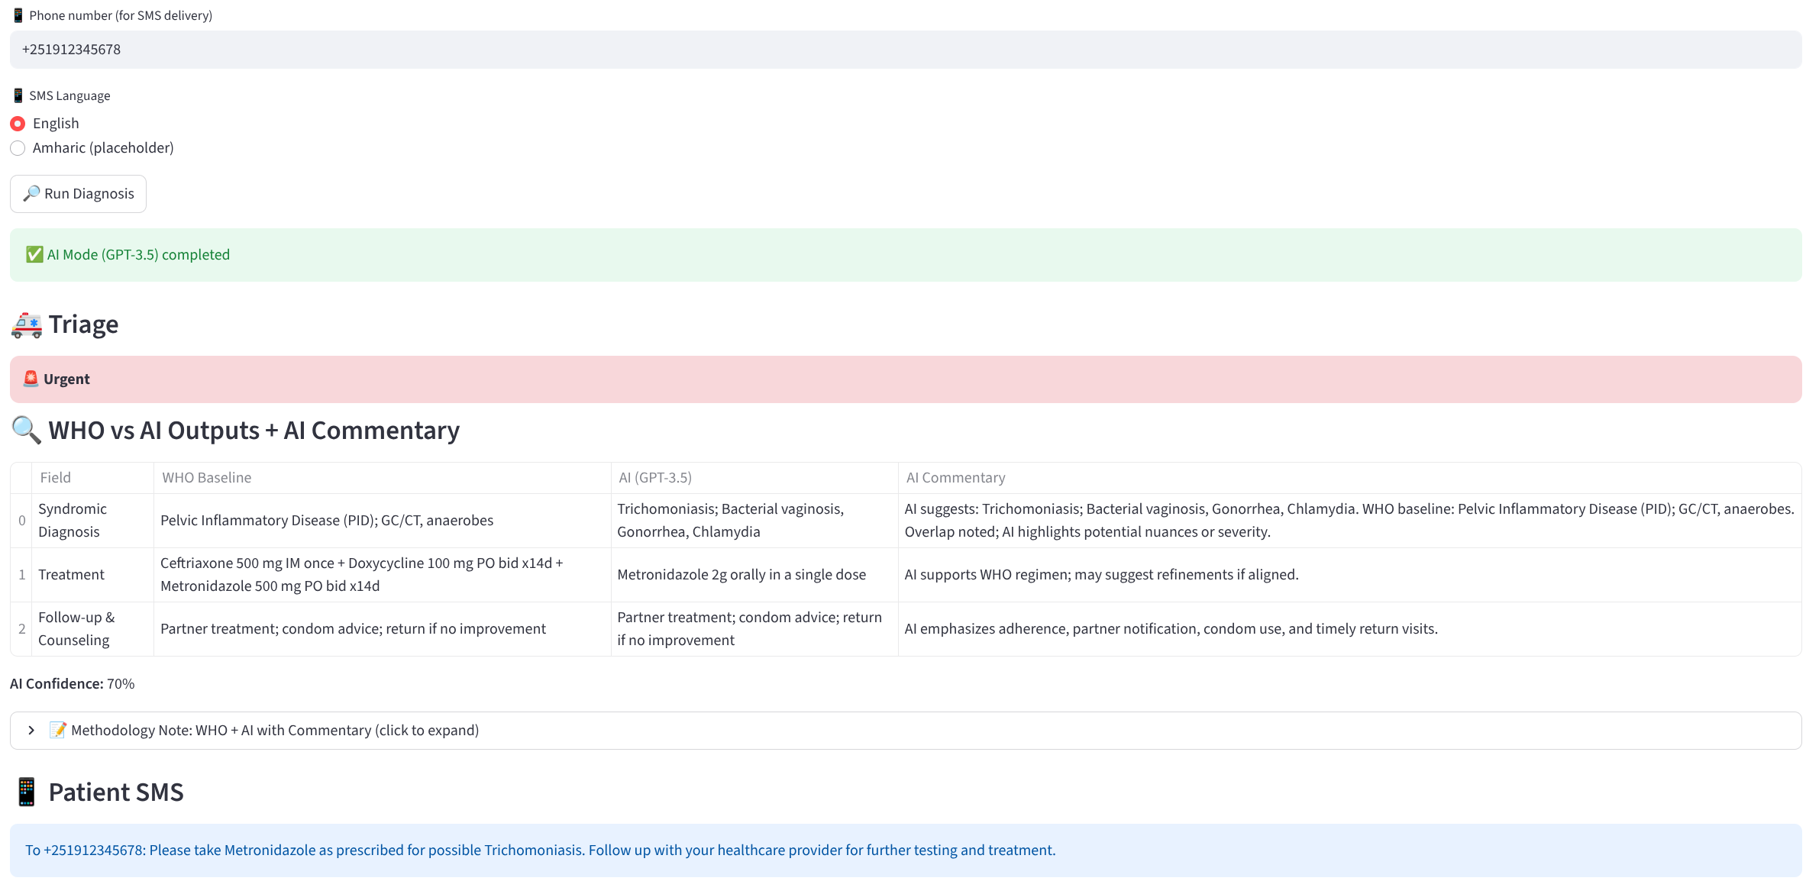

Figure-2:

### **Overall Performance**

Overall, the validation exercise demonstrated that SynDx maintains complete consistency with WHO syndromic classifications while offering additional organism-level insights. This dual capability makes the tool particularly useful in low- and middle-income settings where laboratory confirmation is limited but where more specific treatment recommendations and surveillance data are urgently needed. By anchoring its logic to WHO standards and simultaneously refining outputs with AI reasoning, SynDx emerges as a reliable, interpretable, and practical decision support tool for frontline STI care. The prototype dashboard is publicly accessible at:  
<https://medsynapse-dashboard-mdyexnsatpf452nyk48rsf.streamlit.app/>

### **User Transparency and Commentary**

A distinctive feature of the dashboard was the commentary layer that compared WHO and AI outputs directly. In cases of agreement, the AI reinforced the reliability of the WHO classification and highlighted factors such as high pain scores or the presence of risk behaviors. In cases of partial mismatch, the AI commentary explicitly noted the overlap and provided rationale, for example clarifying that vaginal discharge syndromes may mask early pelvic inflammatory disease. This interpretive dimension improved the transparency of AI reasoning and demonstrated how such tools could augment clinician awareness rather than act as opaque black boxes.

### **Deployment and Accessibility**

After verification, the SynDx prototype was deployed on Streamlit Cloud, enabling secure browser-based access without installation requirements. The deployed tool is publicly accessible at: <https://medsynapse-dashboard-mdyexnsatpf452nyk48rsf.streamlit.app/>

Deployment confirmed that the system could be scaled beyond local testing and accessed across devices, including desktops and smartphones. This demonstrated the feasibility of lightweight cloud-based deployment for clinical decision support in low-resource settings.

## **Discussion**

The findings from this prototype evaluation highlight the feasibility and potential of SynDx as a next-generation clinical decision support system for syndromic STI management. By demonstrating complete alignment with the World Health Organization (WHO) 2016 syndromic guidelines after minor corrections to its internal logic, SynDx has established a strong foundation of validity. At the same time, the tool extends beyond replication of established algorithms by introducing artificial intelligence (AI)-driven refinements that add diagnostic granularity and interpretive support.

### **Alignment with WHO Syndromic Management**

The cornerstone of this prototype was its ability to replicate the WHO syndromic approach, which remains the standard in low- and middle-income countries (LMICs) where diagnostic infrastructure is limited. Our validation with 25 synthetic cases showed that SynDx consistently produced the same syndrome categories as the WHO algorithm, achieving 100% agreement after addressing an initial inconsistency in handling urethral discharge cases. This high level of concordance reassures clinicians and policymakers that the platform can be trusted to maintain compliance with international standards while offering enhanced functionality.

### **Added Value of Organism-Specific Refinement**

One of the most important contributions of SynDx lies in its ability to refine broad syndromic categories into organism-level detail. For example, while WHO guidelines identify “genital ulcer disease” as a single syndrome, SynDx differentiates among syphilis, herpes simplex virus (HSV), and chancroid as probable causes. Similarly, urethral discharge is further resolved into gonorrhea and chlamydia. These refinements do not replace syndromic management but rather enrich it, offering clinicians a clearer picture of the likely etiologies. This is especially valuable in LMIC settings, where empirical treatments may be broad, costly, and prone to driving antimicrobial resistance (AMR). By narrowing the differential within the syndromic framework, SynDx supports more rational prescribing, aligning directly with global AMR containment priorities.

### **Role of AI in Supporting Clinical Interpretation**

Beyond classification, SynDx employs AI to provide interpretive commentary, bridging the gap between static algorithms and the complexity of real-world clinical presentations. For each case, AI contextualizes WHO outputs, highlighting overlaps, potential co-infections, or risk-related nuances. For example, in cases with HIV-positive status or pregnancy, SynDx can emphasize urgency, recommend closer follow-up, or flag the need for referral to higher-level care. This interpretive layer offers clinicians more than just a diagnosis; it provides actionable insights grounded in both evidence and patient-specific context. Such a hybrid model—anchoring decisions in WHO rules while layering AI reasoning—ensures that AI functions as an enhancer rather than a replacement, which is critical for clinical adoption and trust.

### **Implications for Public Health and Surveillance**

The utility of SynDx extends beyond individual patient care. By systematically structuring data on symptoms, syndromic categories, probable etiologies, and follow-up recommendations, the tool can generate case-level datasets that feed into national surveillance systems. This dual function has significant potential for Ethiopia and other LMICs, where real-time data on STI trends and treatment outcomes are scarce. For institutions like the Ethiopian Public Health Institute (EPHI), SynDx could serve as both a clinical support tool and a digital surveillance asset, informing strategic planning, resource allocation, and monitoring of AMR patterns. The alignment of clinical decision-making with public health intelligence makes SynDx unique compared to purely clinical reference apps.

### **Comparison to Existing Tools**

Previous digital health interventions for STIs, such as the CDC’s STI Treatment Guidelines app or reference tools developed in Uganda, Kenya, and India, primarily serve as repositories of static information. While valuable for reference, they lack real-time diagnostic reasoning, integration with WHO syndromic flowcharts, or structured data capture for surveillance. SynDx addresses these gaps by combining WHO’s standardized algorithms with AI-based interpretive capabilities, offering both a decision-support function and a data-generation platform. This positions SynDx at the intersection of clinical care and digital epidemiology.

### **Limitations and Future Work**

Several limitations must be acknowledged. First, this prototype was validated using synthetic patient cases rather than real-world clinical encounters. While synthetic data provided a controlled environment for initial testing, field validation is essential to assess usability, diagnostic accuracy in practice, clinician acceptance, and patient outcomes. Second, although the organism-specific refinements provide added value, they remain probabilistic approximations rather than laboratory-confirmed diagnoses. These should therefore be interpreted as guidance for clinical reasoning rather than definitive results. Finally, the app has yet to be integrated with key implementation features such as secure log-in, patient record storage, or SMS-based health education in local languages, which are critical for large-scale deployment.

Future work will involve piloting SynDx in primary healthcare facilities under routine conditions, incorporating clinician feedback, and refining the AI commentary based on local epidemiology. Expanding the platform to include laboratory integration, antimicrobial resistance surveillance, and multi-language patient education will further enhance its value. Additionally, ensuring interoperability with national health information systems and global standards such as HL7 FHIR and OMOP CDM could make SynDx a versatile tool for both clinical care and research.

### **Conclusion**

In summary, SynDx successfully harmonizes WHO syndromic guidelines with AI reasoning to deliver a reliable, context-sensitive digital decision support tool for STI management. Its ability to replicate WHO outputs while refining them into organism-level differentials addresses a long-standing limitation of syndromic management and offers a pathway for more precise and rational STI care. By coupling clinical decision support with surveillance potential, SynDx represents a promising innovation at the convergence of AI, public health, and digital health.